CN530 Simulation Assignment 1

**Abstract**

In this simulation assignment what was found was that a surface reflectance cannot be inferred by only sampling the uniform part of the surface due to humans having to estimate the ratio of reflectance’s across boundaries. Consequently, our perception of surface reflectance is partly based on sampling the edges and the reflectance of two surfaces relative to each other. This is because surface reflectance is not constant for humans. A differential equation solved in equilibrium was used to model neural activity over time to different stimuli. When the background value increased linearly showed a logarithmic decrease in step changes, but a logarithmic increase in background value showed a linear step increase. Simultaneous contrast modeling showed that human observers cannot necessarily differentiate the brightness of the image regions even if brightness and physical reflectance are constant over time in this stimuli. Since an image is constructed with a combination of an objects constant reflectance and a steady illumination in this case, our perceived brightness between regions is based on contextual effects. As a result of that we looked at what happens when gray patches of the simultaneous contrast stimulus get closer to each other in 1D space. It was found that as the distance decreases, there is a fusion or overlap between the contrasting stimuli where there will be a sharp transition from one patch of gray to another similar to the Craik-O’Brien-Cornsweet Effect. Ultimately, the importance of this simulation was showing how our visual systems perceives the physical properties of surface reflectance.

**Introduction**

Surface reflectance is the fusion of physical properties and perceptual integration which results in our ability to see the contrast between multiple surfaces. Humans perceive reflectance and surface color based on contrasting with other stimuli and utilizing edges. Another aspect of visual perception is simultaneous contrast which is how the shades or colors of two different objects impact one-another. This can be seen in visual illusions which contrast gray patches where two separate same-shade rectangles are surrounded by different rectangles with one darker and one lighter shade of gray. This results in the one inner rectangle looking brighter than the other based on the simultaneous contrast between the two objects. The final phenomenon explored in this simulation assignment was Contextual Effects which is similar to simultaneous contrast where the distance between gray patches was changed to see the dynamics of the perceived reflectance of the visual stimuli.

In order to look at all of these properties, a neural model incorporating decay dynamics, excitatory and inhibitory terms was used to show neural activity over time. What we expect to see is that we cannot infer the reflectance by only sampling the uniform part of the surface, but we have to contrast two opposing stimuli in order to build our visual space. Furthermore, a linear change in background value is expected to show as a logarithmic decrease in the step function while a logarithmic increase in background values will show a linear step function increase between each graph. Finally, a simultaneous contrast stimulus in this neural model will show that it becomes harder to differentiate between the stimuli and the percept becomes harder to differentiate. However, if the distance is larger, even if the object or color in greater quantity will have a decreased influence on changing the smaller stimulus.

**Methods**

MATLAB was used for this simulation assignment. The function that was modeled was a first order differential equation with decay dynamics, excitatory and inhibitory terms. The equation used was:

$$\frac{dx_{i}}{dt}=\left(-Ax_{i}\right)+\left(B-x_{i}\right)*I_{i}-\left(C+x_{i}\right)*\sum_{i≠k}{I_{k}}$$

This equation measures the activity $x_{i}$ based on three parts: the passive decay $–Ax_{i}$, the shunting excitation $\left(B- x_{i}\right)I_{i}$, and the shunting inhibition $\left( C+x_{i}\right) \sum_{j≠i}{I_{j}}$. In this case an added C term is related to the Nernst potential for potassium was added to depict hyperpolarization of the cell, giving the property that can help suppress uniform inputs. Within Matlab, the two equations were solved in equilibrium resulting in the equation: $x_{i}=\frac{BI_{i}-C*L_{j}}{A+I_{i}+L_{j}}$.

**Results**

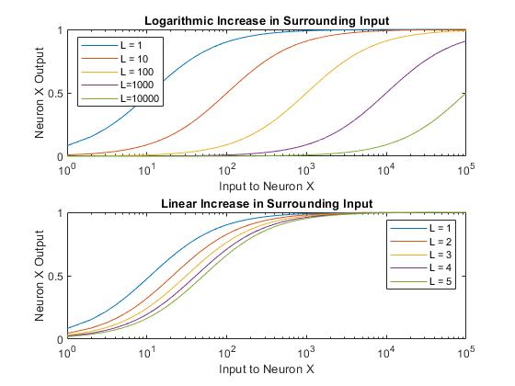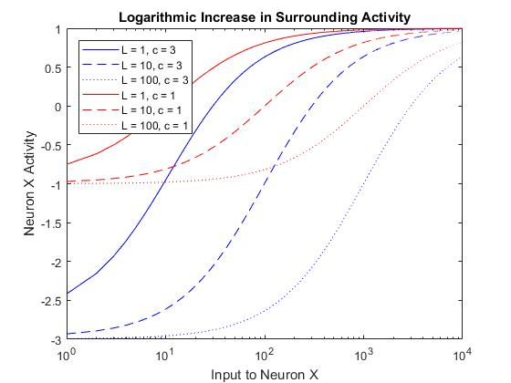

**Figure 1.** Contrast between Logarithmic and Linear increase in surrounding Stimulus. A) Shows the difference between logarithmic increase with the C term in the equation held constant. B) Shows the logarithmic increase in surrounding activity with a changed C term from the equation. The same result occurs in the linear increase. By increasing C, the lower bound for activity becomes negative requiring more input.

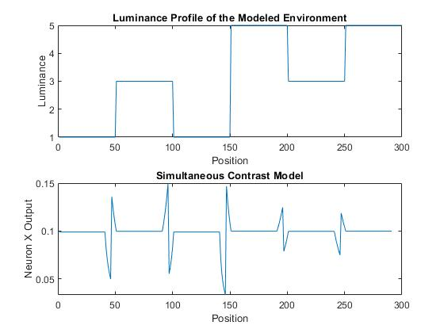

B)

A)

**Figure 2.** Simultaneous Contrast model. A) The luminance profile of a simultaneous contrast stimulus. B) A neuron response profile was provided over a simultaneous contrast stimulus. The spikes correspond to a shift in luminance/contrast.

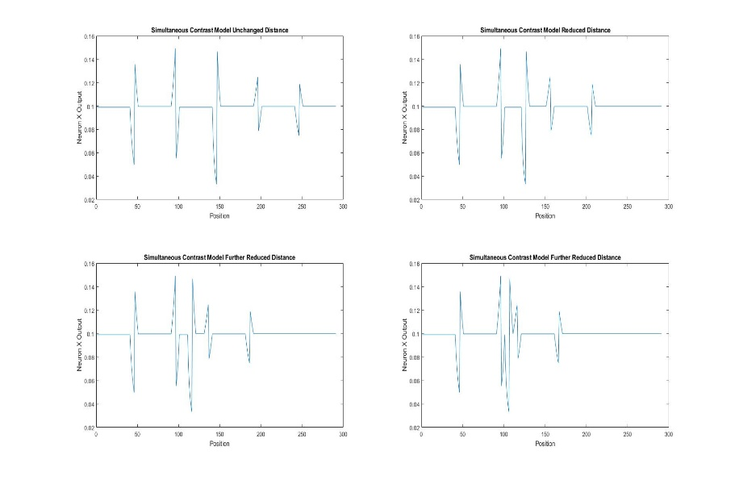

**Figure 3.** Distance Dependent Simultaneous Contrast Model. In this figure the distance is reduced between the main stimulus.

1. Contextual effects reducing distance between gray patches

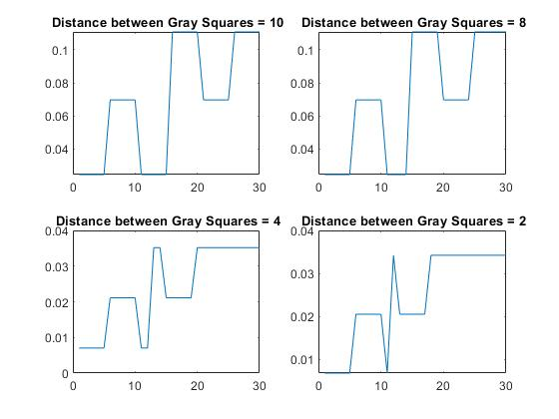

**Figure 4.** Contextual effects reducing distance between gray patches. A-D) distance decrease between gray squares from 10 to 2. As the distance decreases, there is a sharper shift in contrast in some cases, but in others a fusion.

**Discussion**

**Question 1:**

1. Surface reflectance cannot be inferred by only sampling the uniform part of the surface due to our visual system utilizing a ratio function that contrasts between stimuli in order to find a comparison. If in 2a we had a completely flat luminance profile, the resulting stimulus model would be a flat line due to a lack of contrasting luminance.
2. Two surfaces’ reflectance on either side of an edge could be inferred by sampling the neighborhoods around the edge as shown in figure 2a-b. When there is a switch between edges of a stimulus we can infer the reflectance based on the level of activation. However, there is a level of ambiguity based on local information such as occlusion of the parts in the neighborhood sampled. Consequently, it might not result in a completely accurate perception.
3. When we consider two surfaces relative to each other, we can infer their reflectance based on our perceptual shift in activation and their luminance profile that comes from the light. In figure 2 we can see when a different surface begins there is an immediate switch and contrast between the two surfaces.

Question 2:

1. A linear versus logarithmic increase in surrounding input shows that a logarithmic increase holds our activation constant, but a linear one slowly decreases in its steps between S curves. (Fig. 1a) However, it is important to note that the S curves are not exactly parallel in the beginning, but after each logarithmic step (i.e. Intensity increase) they gradually become parallel.
2. When the C value is changed, we see that the activity of Neuron X needs a specific level of input to have positive activity. (Fig. 1b) Furthermore, when the C value is increased, we see a downward shift of neuronal activity, forcing more input to have positive activity. This provides the ability to have a dynamic firing range in a neuron based on the size of the surround inhibition, keeping the perceived reflectance profile consistent regardless of the true luminance from the environment.

Question 3:

1. Based on figure 2, we can see that when a luminance profile is given, the nodes will reflect the brightness of the image regions, but not completely. Essentially our perception of surface reflectance is not constant and neither is our perception of surface color. Therefore, the main discrepancy is in illusions such as ones with simultaneous contrast where one inner gray square appears brighter than another when surrounded with a different shade. Even through figure 2 shows us that when the surface is changed, there will be a ratio taken near the edges of the image while the interior of the region will be suppressed. Consequently, the ratio between environments reflects our brightness of the image regions.

Write a thorough interpretation of your findings. Do corresponding model nodes reflect the brightness of the image regions as reported by human observers? Elaborate on any discrepancy and consistency.

Question 4:

**a)** Based on figure 4 there is a fusion of stimuli as the simultaneous contrast stimulus get closer to each other in a 1D space, resulting in the creation of new edges. In figure 4d with a distance of 2 between gray patches we see the creation of a new edge. Similarly in figure 3a contrasted with figure 3d, multiple edges occur as multiple surfaces get closer to each other. Consequently, our neuron model picks up edges, but does not smooth out any uniform surface. What could be assumed is that as we further reduce the distance between multiple surfaces, the edge differences become much more stark in what is being perceived. However, a human might not necessarily be able to find consistency in that scenario.

**Concluding Section**:

Overall our neuron model has a few distinct strengths and weaknesses in the replication of brightness perception. It can clearly tell us when a surface is changing based on an input stimulus. The logarithmic increase to have a consistent step between changes in background luminance that is present in humans can also be replicated. The ability to hold that consistency between environments is crucial to our perception. However, it seems that as the distance between stimuli decreases, the neuron model cannot necessarily replicate our perception of edges extremely close to each other.